High-resolution Cloud Climatology for Global Land Areas

Adam M. Wilson & Walter Jetz

# Introduction

Clouds are an extremely important component of the global climate system, affecting energy balance, latent heat flux, radiation flux, and moisture transport1. Cloud cover also affects many ecological processes, such as drought stress2, tree growth2, available photosynthetically active radiation3, eco-physiology4, and animal behavior5,6 and can vary drastically over small spatial grains (<2km) due to topography7 and land cover8. In the ecological community, there is growing recognition of the importance of fine-grain species-habitat (“microhabitat”) associations in a variety of systems9 and thus a need to increase the spatial resolution of environmental datasets for global change biology and biogeographic research10. Here we introduce a new high resolution (30-arcsecond, ≈1km) set of monthly cloud frequency climatologies and related metrics derived from twice daily observations over the full 2000-2014 MODIS archive for global land areas. The climatologies were validated using 40 years of cloud observations from over 5,300 globally distributed weather stations. These data provide a new lens through which to understand the fine-grain spatial variability of global cloud cover.

# Main

Global change biology relies upon climate data that adequately capture the abiotic environment experienced by organisms and there is growing evidence of the importance of micro-climatic (100-103m) variability in driving organisms’ spatial distributions and performance10. However, the most ecological analyses at regional to global scales rely on climate datasets that have been interpolated between meteorological stations and tend to smooth out important fine-grain variability. Topographic morphology, for example, has profound effects on clouds and precipitation at grains finer than 2km in mountainous areas7 and land cover can affect mesoscale convective events, cloud cover, and precipitation8, which in turn affects numerous ecological processes. For example, Graham, et. al3 found that seasonal availability in light due to cloud cover limited CO2 uptake in a rainforest tree species. Goldsmith, Matzke, and Dawson11 found that variability in cloud frequency explained in leaf wetness in tropical montane and pre-montane cloud forests at sites only 2km apart. Fischer, Still, and Williams2 reported that persistent cloud cover on Santa Cruz Island (California, USA) reduced annual drought stress in bishop pine (*Pinus muricata*) by 22-44% compared to less cloudy areas further inland. Hare and Cree4 experimentally altered available radiation to simulate increased cloud cover and found it lowered maternal pregnancy success and slowed growth rates of female McCann’s skinks (*Oligosoma maccanni*). However, these studies all had very limited spatial extents and required either local cloud observations or extensive processing of satellite observations.

Existing cloud climatologies are typically available and analyzed at relatively coarse grains (see **table SM X**). The majority of global analyses of cloud climatologies have been conducted at grains coarser than 10km and often over 100km12–14 despite our understanding of important cloud dynamics operating at grains as fine as 1-2km7,8,15,16. For example, the recent GEWEX systematic review of satellite-derived cloud climatologies12 and all MODIS level three (L3) atmosphere products are summarized at 1**°** (≈110km) resolution. While this resolution is appropriate for study of global cloud dynamics (and necessary for cross-platform comparison), it is far too coarse to capture fine-grain variability important in many ecological questions11.

There are a few examples of finer-grain climatologies based on other sensors, such as HIRS13 (~20km), AVHRR PATMOS-x17 (~11km), and GridSAT18 (~8km), but these are 8-20 times coarser than possible with the MOderate resolution Imaging Spectroradiometer (MODIS). To date there have been two efforts to produce high-resolution (<=1km) cloud climatologies from the MODIS archive. One is based on the MOD35 250m visible cloud mask19, but is spatially bounded to the tropics and incorporates only seven years of data (2000-2006). Additionally, these data were derived from the problematic collection 5 MODIS (MOD35) cloud mask and thus contain significant land-cover and processing-path biases in cloud frequency20. The other MODIS-derived 1km cloud climatology21,22 avoids the problematic MOD35 algorithm through a simple cloud masking procedure based on scaled visible wavelength (RGB) images from the MODIS “Rapid Response” system23. Douglas, et. al., developed an algorithm that applies a user-defined threshold to convert RGB “brightness” to “cloudiness.” However, the product is based on a derivative of surface reflectance data rescaled for visual appeal23, is strongly dependent on the brightness threshold, and is problematic over high-albedo surfaces (such as urban areas or snow). Furthermore, this approach does not exploit more sophisticated tests used in most cloud detection algorithms such as cloud-top infrared temperature12 and is only available for scattered regions around the globe. As a result, cloud cover is infrequently used in ecological studies, likely due primarily to the complexity of attaining it at sufficiently high resolution for a study region. For example, to obtain cloud frequency at the two locations in the study mention above, Goldsmith, Matzke, and Dawson11 had to process a decade of four daily swath-level (ungridded) satellite images (over 14,000 files).

In this study we develop and validate a 30-arc-second (≈1km) monthly global cloud frequency climatologies (MODCF) using a MODIS cloud mask included in the MOD09GA surface reflectance product (see methods and Supplementary Materials for details). Overall, the MODCF product captures global cloud frequency patterns, with mean annual cloud frequencies greater than 80% over much of equatorial South America, the Congo River basin in Africa, and Southeast Asia. Intra-annual variability (standard deviation of mean monthly values) is highest over India, Brazil, and the African savannah. However, the novelty and value of this product is in the unprecedented spatial detail of monthly cloud dynamics.

REGIONAL DESCRIPTIONS: explanation of high resolution regional patterns/processes (andes, south Africa), inter vs. intra annual variability,

Cloud extremes: highest recorded cloud frequencies, highest seasonality, etc.

The MODCF explains nearly 80% of the variability in cloud cover observed at a global set of 5,388 weather stations. Furthermore, the MODCF data was nearly as accurate over the full station record (1970-2009) versus the MODIS-era (2000-2009) alone. This confirms that the MODCF, although it only represents 15 years of observations (2000-2014), is a useful metric of multi-decadal fine-grain spatial patterns of cloud frequency.

POTENTIAL CASE STUDIES/EXAMPLE APPLICATIONS

Cloud forests?

Due to the reliance on relatively coarse and interpolated datasets, we are likely overestimating the spatial homogeneity of the abiotic conditions driving the distribution and abundance of organisms. In addition to the biogeographic uses detailed above, we also envision that this product will have applications in climate modeling, solar power development25,26, tourism27, or even real estate28.

Applications

# Extra Bits

Quintero, et. al, recently evaluated the use of MODCF in a test of the “Asynchrony of Seasons Hypothesis” which suggests that seasonal differences in climate-derived food availability could lead to asynchronous breeding seasons and gene flow barriers. The study was conducted using genetic data from ~1600 individuals of 74 species of bird from locations around North and South America. WorldClim monthly precipitation24 and the MODCF cloud climatologies were both evaluated as proxies for the seasonality of food availability and MODCF improved model performance.

Furthermore, cloud frequency can be a better predictor than interpolated precipitation for plant distributions29. Additionally, changes in cloud patterns (including, but beyond changes in precipitation) have multi-fold consequences for biodiversity and ecosystems and thus require fine-grain understanding and monitoring4.

Cloud frequency is a vitally important integrative predictor in biogeographical processes, but there are no globally available, high-quality, high-resolution, cloud frequency data sets.

# References

1. Stephens, G. L. & Kummerow, C. D. The remote sensing of clouds and precipitation from space: A review. *Journal of the Atmospheric Sciences* **64,** 3742–3765 (2007).

2. Fischer, D. T., Still, C. J. & Williams, A. P. Significance of summer fog and overcast for drought stress and ecological functioning of coastal California endemic plant species. *Journal of Biogeography* **36,** 783–799 (2009).

3. Graham, E. A., Mulkey, S. S., Kitajima, K., Phillips, N. G. & Wright, S. J. Cloud cover limits net CO2 uptake and growth of a rainforest tree during tropical rainy seasons. *PNAS* **100,** 572–576 (2003).

4. Hare, K. M. & Cree, A. Exploring the consequences of climate-induced changes in cloud cover on offspring of a cool-temperate viviparous lizard. *Biological Journal of the Linnean Society* **101,** 844–851 (2010).

5. Clench, H. K. Behavioral Thermoregulation in Butterflies. *Ecology* **47,** 1021–1034 (1966).

6. Grubb, T. C., Jr. Weather-Dependent Foraging Behavior of Some Birds Wintering in a Deciduous Woodland: Horizontal Adjustments. *The Condor* **79,** 271–274 (1977).

7. Houze, R. A. Orographic effects on precipitating clouds. *Reviews of Geophysics* **50,** (2012).

8. Wang, J. *et al.* Impact of deforestation in the Amazon basin on cloud climatology. *PNAS* **106,** 3670–3674 (2009).

9. Ledo, A., Burslem, D. F. R. P., Condés, S. & Montes, F. Micro-scale habitat associations of woody plants in a neotropical cloud forest. *Journal of Vegetation Science* n/a–n/a (2012). doi:10.1111/jvs.12023

10. Potter, K. A., Arthur Woods, H. & Pincebourde, S. Microclimatic challenges in global change biology. *Global Change Biology* **19,** 2932–2939 (2013).

11. Goldsmith, G. R., Matzke, N. J. & Dawson, T. E. The incidence and implications of clouds for cloud forest plant water relations. *Ecology Letters* **16,** 307–314 (2013).

12. Stubenrauch, C. . J. *et al.* Assessment of global cloud datasets from satellites: Project and database initiated by the GEWEX Radiation Panel. *Bulletin of the American Meteorological Society* 130117123745009 (2013). doi:10.1175/BAMS-D-12-00117

13. Wylie, D., Jackson, D. L., Menzel, W. P. & Bates, J. J. Trends in global cloud cover in two decades of HIRS observations. *Journal of climate* **18,** 3021–3031 (2005).

14. Pavolonis, M. J., Heidinger, A. K. & Uttal, T. Daytime global cloud typing from AVHRR and VIIRS: Algorithm description, validation, and comparisons. *Journal of Applied Meteorology* **44,** 804–826 (2005).

15. Allard, J. & Carleton, A. Mesoscale Associations Between Midwest Land Surface Properties and Convective Cloud Development in the Warm Season. *Physical Geography* **31,** 107–136 (2010).

16. Durieux, L., Machado, L. A. T. & Laurent, H. The impact of deforestation on cloud cover over the Amazon arc of deforestation. *Remote Sensing of Environment* **86,** 132–140 (2003).

17. Foster, M. J. & Heidinger, A. PATMOS-x: Results from a Diurnally Corrected 30-yr Satellite Cloud Climatology. *J. Climate* **26,** 414–425 (2012).

18. Knapp, K. R. *et al.* Globally Gridded Satellite Observations for Climate Studies. *Bulletin of the American Meteorological Society* **92,** 893 (2011).

19. Mulligan, M. MODIS MOD35 pan-tropical cloud climatology. *MODIS cloud climatology, Version 1* (2006). at <http://www.ambiotek.com/clouds/>

20. Wilson, A. M., Parmentier, B. & Jetz, W. Systematic landcover bias in Collection 5 MODIS cloud mask and derived products – a global overview. *Remote Sensing of Environment* **in press,** (2013).

21. Douglas, M., Beida, R. & Dominguez, A. Developing high spatial resolution daytime cloud climatologies for Africa. in *Preprints, 29th Conf. on Hurricanes and Tropical Meteorology, Tucson, AZ, Amer. Meteor. Soc. P* **2,** (2010).

22. Douglas, M. A high spatial resolution satellite-based cloud climatology for biogeographical applications. in *6th International Conference* (International Biogeography Society, 2013). at <http://www.nssl.noaa.gov/projects/pacs/web/MODIS/>

23. Descloitres, J. *et al.* The MODIS rapid response project. in *Geoscience and Remote Sensing Symposium, 2002. IGARSS ’02. 2002 IEEE International* **2,** 1191–1192 vol.2 (2002).

24. Ramachandra, T. V., Jain, R. & Krishnadas, G. Hotspots of solar potential in India. *Renewable and Sustainable Energy Reviews* **15,** 3178–3186 (2011).

25. Tapiador, F. J. Assessment of renewable energy potential through satellite data and numerical models. *Energy Environ. Sci.* **2,** 1142–1161 (2009).

26. Rutty, M. & Scott, D. Differential climate preferences of international beach tourists. *Clim Res* **57,** 259–269 (2013).

27. Kaplanski, G. & Levy, H. Real estate prices: An international study of seasonality’s sentiment effect. *Journal of Empirical Finance* **19,** 123–146 (2012).

28. Hijmans, R. J. *et al.* Very high resolution interpolated climate surfaces for global land areas. *International Journal of Climatology* **25,** 1965–1978 (2005).

29. Sklenář, P., Bendix, J. & Balslev, H. Cloud frequency correlates to plant species composition in the high Andes of Ecuador. *Basic and Applied Ecology* **9,** 504–513 (2008).

30. Markham, C. G. Seasonality of Precipitation in the United States. *Annals of the Association of American Geographers* **60,** 593–597– (1970).

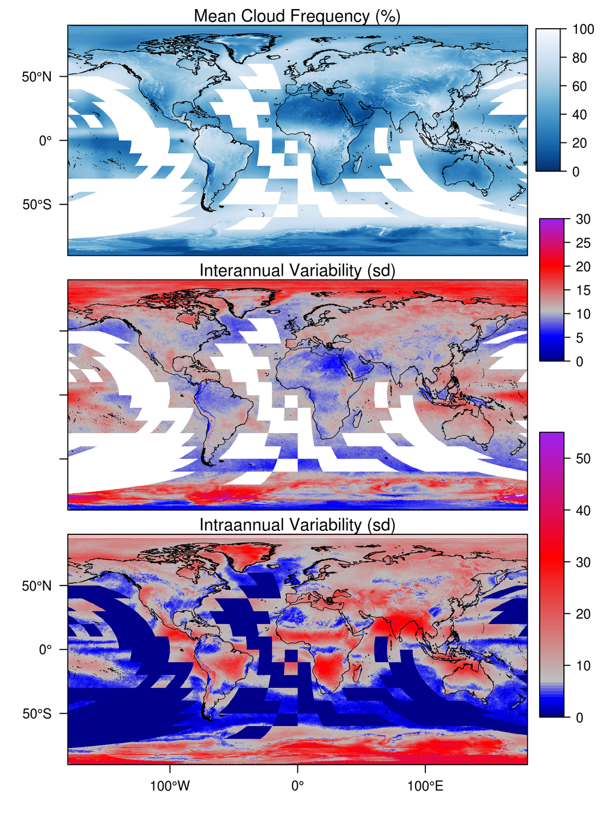

Figure : a, mean annual cloud frequency (%), b, Interannual variability, and c, intra-annual variability.

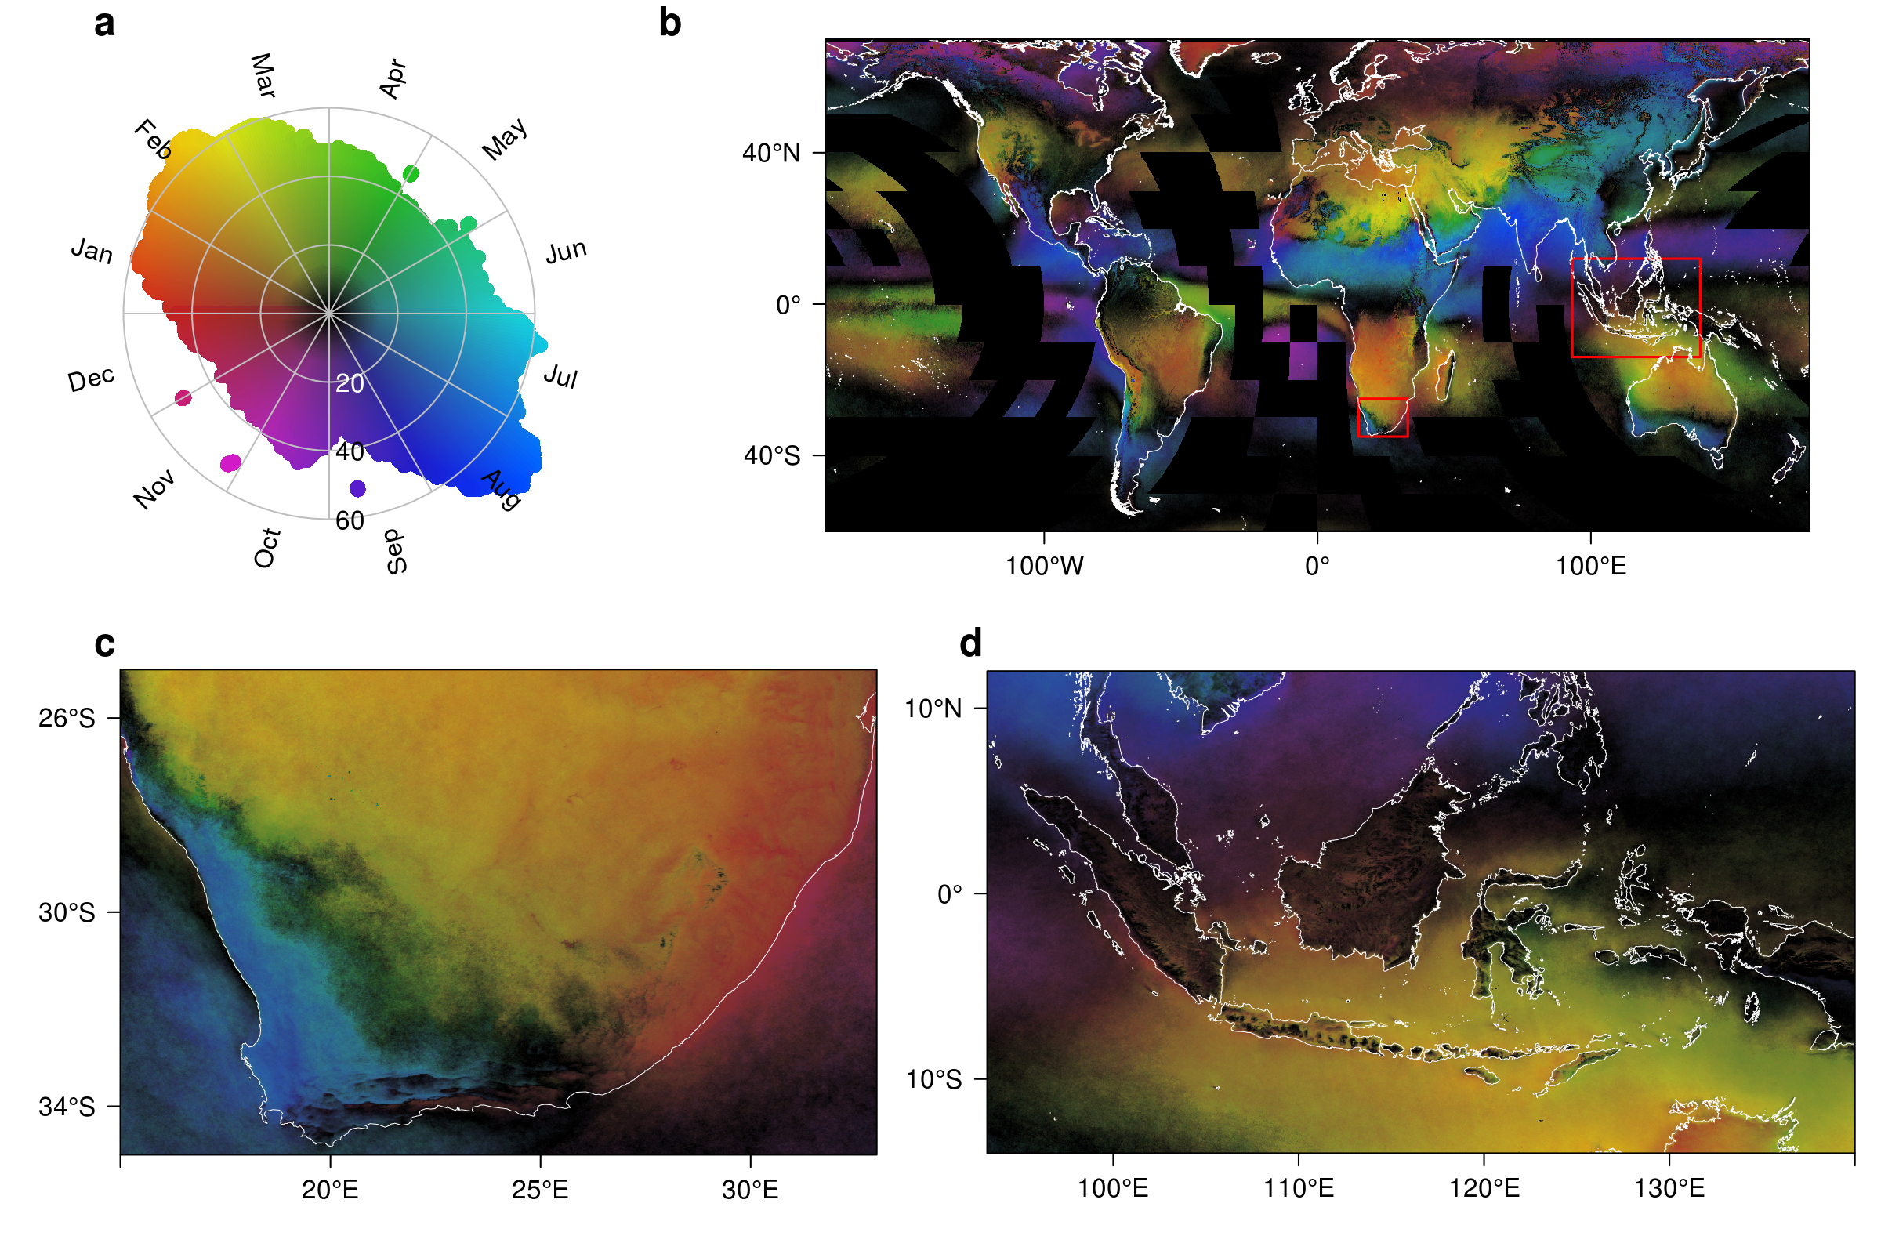

Figure : a-d, Seasonal cloud concentration30 derived from monthly mean cloud frequencies. a, Color key illustrating the distribution of global cloud seasonality and concentration. The hue indicates the month of peak cloudiness, while the saturation indicates the magnitude of the concentration ranging from 0 (all months are equally cloudy) to 100 (all clouds are observed in a single month). B, Global distribution of seasonal cloud concentration with two red boxes indicating the locations of panels c and d. Coastlines shown in white. Data are available only for MODIS land tiles resulting in missing data in black tiles over ocean. c, regional plot of Southern Africa illustrating the transition from the mediterranean climate in the southwest to the summer rainfall region in the northeast. Note the incursions of summer rainfall (red colors) along the southern coast. d, Regional plot of the Indo-Pacific illustrating the transition from JJA to DFJ cloudiness with little seasonality (dark colors) on mountains.

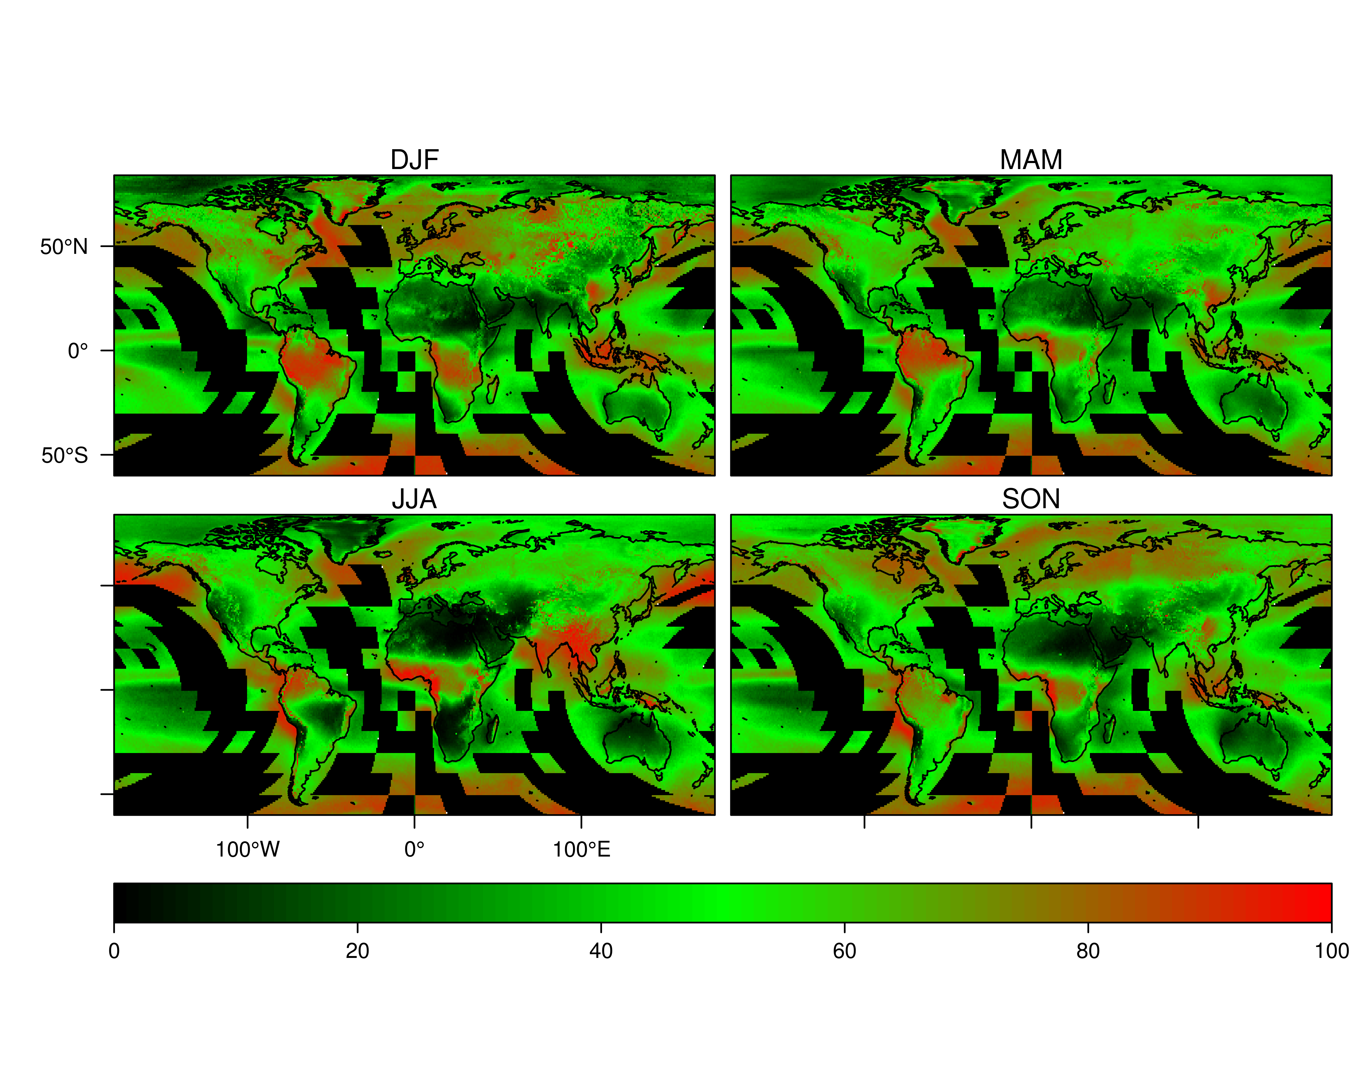

Figure : Near-global 1-km seasonal mean (DJF: December, January, February; MAM: March, April, May; JJA: June, July, August; SON: September, October, November) cloud frequency (proportion of days flagged as cloudy) derived from MODIS MOD09 internal cloud mask algorithm over 2000-2012.

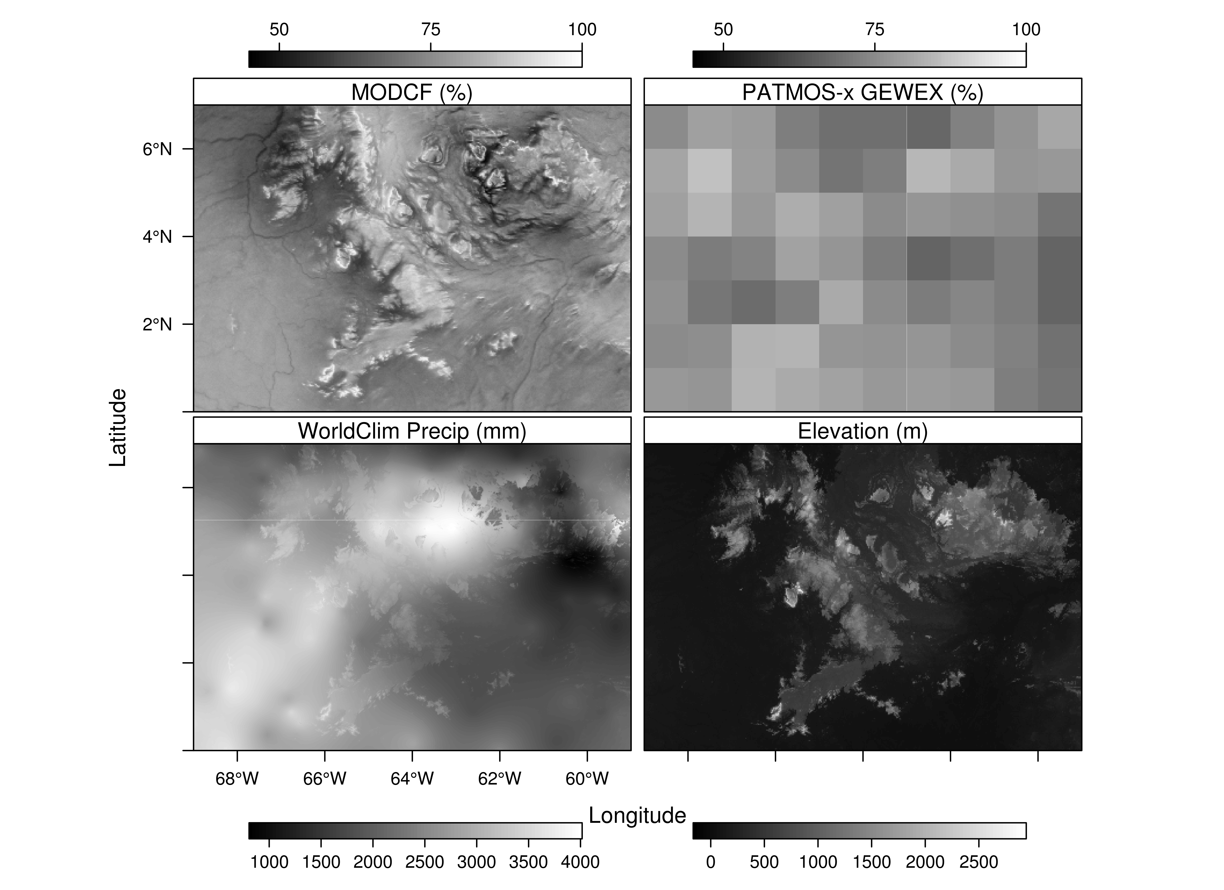

Figure : Comparison of cloud related products for a region near Parque Nacional Jaua-Sarisariñama in Southern Venezuela. Top left: MODCF developed in this paper (~1km resolution). Top right: PATMOS-x AVHRR data formatted for the Global Energy and Water cycle Experiment (GEWEX) Cloud Assessment (1 degree, ~110km). Lower left: WorldClim mean annual precipitation (mm). Lower right: Elevation (m).

# Methods

In this study we develop and validate a 30-arc-second (≈1km) global monthly cloud frequency climatologies (MODCF) using an alternative MODIS cloud masking algorithm in the MOD09GA surface reflectance product. The cloud detection algorithm includes two reflective and one thermal test that identify pixels with high infrared reflectance anomalies (e.g. fires, sun-glint, and high albedo surfaces) with respect to surface air temperature (see Supplementary Materials for details). We processed the daily February 2000 – March 2014 MOD09GA archive (approximately 260TB of data) to calculate the inter-annual monthly mean and standard deviation of cloud frequency. We then removed artifacts resulting from the incomplete daily coverage of the MODIS orbit and masked high-albedo pixels that led to inflated cloud frequencies in some areas (see Supplementary Materials for details).